

Family Medicine

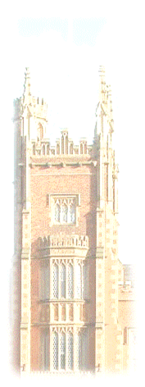 | A course for first and second year medical students  Year 1: The Family Attachment Scheme  Year 2: General Practice Experience  Tutor Guide 2025-26  https://www.med.qub.ac.uk/wp-gp/  Revised August 25 G Kearney

Contents Page

Introduction 2-3
Attendance 3-4
Home visiting 4
Tutor Feedback 4
A Guide to the Individual Tutorials Year 1 5
Session 1 6-8
Session 2 9-10
Session 3 11-12
Session 4 13-14
Session 5 15-16
Marking of Case Report Presentations 16-19
A Guide to the Individual Tutorials Year 2 20
Session 1 21-22
Sessions 2-4 23
Session 5 24
Marking 25
Appendices
1 Accessing the Medical Education Portal 26
2 Teaching Plans 27-30
3 Medical Student Home Visit Guidance 31-35
4 Consent form for Family Attachment scheme 36

Introduction
Thank you for being a GP tutor on the Family Medicine course, especially in these continuing uncertain times. The course runs for the first two years of the undergraduate curriculum and comprises of the “Family Attachment Scheme” (FAS) in first year and the “General Practice Experience” (GPE) course in second year. Where possible we endeavour to assign second year students to the practice they attended in first year. This Tutor Guide covers both the FIRST and SECOND years of the course. Even though you may only be taking first or second year students, it may be useful for you to see what the other part of the course entails.
The intention of this course is for early clinical contact in an experience-based module that is feasible alongside the very demanding clinical environment GPs find themselves in at present. I am therefore happy to speak to any GP tutor about how to make this work in practice.

Connected Primary Care Placements
Family Medicine is the first involvement students will have in their Connected Primary Care Placements as a medical student. As part of a deliberate expansion of time medical students spend learning in Primary Care, we are delighted to say that they will now enjoy Primary Care Placement in all five years of medical school. Evidence has shown that increased time spent in Primary Care increases students’ interest in being GPs in the future https://www.medschools.ac.uk/media/2881/by-choice-not-by-chance.pdf.
We have based the Primary Care Curriculum on a UK-wide model from the Royal College of General Practitioners called “Teaching General Practice” https://www.rcgp.org.uk/getmedia/bd108a4b-50ce-42f0-9de4-c3083a2c8586/teaching-general-practice.pdf.
This link is to the related digital textbook aimed at medical students called “Learning General Practice” https://www.rcgp.org.uk/getmedia/074af536-aaae-4eef-95cb-63ee18e96fda/learning-general-practice.pdf
Under the themes of Person-centred care, Population-centred care and Efficient delivery of care in community settings, we have divided out this curriculum to allow different emphasis in each year, building on what has been learnt previously.
The relevant themes of learning in Year 1 and Year 2 are as follows:-
Develop the Foundations of practice to develop and apply knowledge and understanding around:
Year 1 Family Medicine: Care for the person and care within families
- Holistic care (the biopsychosocial model)
- Social determinants of health
- Medical ethics
- Foundations of Scholarly General Practice

Year 2 Family Medicine: Care within the GP Practice and care within communities
- Holistic care (the biopsychosocial model)
- The doctor-patient relationship
- Information Technology
- Teamwork and leadership
- History of UK general practice
- Current structure of UK general practice
- Funding of UK general practice
- Role of general practice in other countries

In the first year of the FAS, the five tutorials will take place in the practice. Patients/families who would be happy to have two or three students in their homes on a couple of occasions should be chosen for contact. As in previous years, you will need to ensure that the patients/families are available on the date of the second session to meet their students. In the second year GPE component, five tutorials will take place in the practice. The emphasis will be on patient contact and on meeting the Primary Care Team.
I have said before that research carried out in the past (and recent tutor feedback) suggests that your patients are very enthusiastic about the scheme and enjoy the students’ company. Additionally, the FAS receives enthusiastic feedback from the students and received particular mention during the GMC visit in 2017. This brief guide is designed to give you a relatively quick overview and aide memoire for the composition of the first and second year components.

Attendance
Students are expected to attend 100% of tutorials – they are made aware of this. If they are going to miss a tutorial for any reason, they are required to lodge an absence certificate in CME and to let you know as their tutor. If they do not do this, please email gpadmin@qub.ac.uk. Repeating students who have previously passed this module are still expected to fully attend tutorials and patient contacts; these students are not however expected to contribute to a new Case Report in first year or the end of course assessment presentation in second year. You will be specifically told if any of your cohort are repeating. I suggest for first year, adding a repeating student to an existing pair may work best in case there are any attendance issues.

Home visiting
We have created a Home Visit guidance document for practices which may be helpful when considering how best to involve students in this activity.
https://www.qub.ac.uk/sites/qubgp/Resources/

Tutor feedback
In line with the feedback that practices now receive for teaching students in Years 3-5, a new mechanism will be in place for 25/26 to allow more specific feedback for GP tutors who teach on the Family Medicine course.

A Guide to the Individual Tutorials Year 1

Year 1 The Family Attachment Scheme

Preparing for the students
I am delighted that we continue with a ‘normal’ Family Attachment scheme with student group size back to normal. I am once again asking you to find patients/families who are willing to have a small group of students in their home for early clinical contact on a couple of occasions. You may find it useful to discuss with your colleagues which patients you could approach to take part in the scheme. It would be ideal if you could arrange with these patients before the first tutorial but as always, there will also be time to make these arrangements between the first and second tutorials. Generally, the students are split into groups of two or three for each patient/family. Make sure you have a room available for your first tutorial, have read through the guideline material and have thought through how you will deliver the tutorial.
The big change for 25/26 is that we are no longer using the Family Attachment report for marking, instead students in their pairs/trios will deliver a Case Report presentation in their last session with you. In addition, students will be
We will continue the focus on “Cultural Humility”, which essentially involves “becoming the student of the patient”. I will teach the students about this in their introduction to Family Attachment and this will be supported by a video and some links for further reading. I hope you will again touch on it in the first tutorial and I have students to specifically refer to it in their Case Report presentation. It is not necessary for students or tutors to have a sophisticated understanding of this concept, however as you read a little about it under Session one, I hope you will recognise it as the ethos of the course and how you teach it (without previously knowing it under this name).

Family Attachment Session 1- Introduction to the Family Attachment Scheme
This first session will allow students to get to know each other and you to get to know the group. You can explain to them about the practice and could offer them a tour. The object is to get students thinking about communication which forms a key part of what the Family Attachment scheme is about. The session will thus be an important contributor to this year’s workshops on Clinical Communication with which there will be some overlap.

Learning outcomes for this session are:
- Be able to discuss why clinical communication is so important
- Begin to understand the characteristics of satisfactory and unsatisfactory communication
- Gain an understanding of the Aims and Objectives of the Family Attachment Scheme
- Consider how to “become the student of the patient” using Cultural Humility

Preparation:
Students will be asked to become familiar with Good Medical Practice which was revised in 2024 and now explains the duties of a health professional (as opposed to a doctor). Students should be prepared to discuss this in your tutorial group. They have also been asked to be familiar with the Cultural Humility resources.

Tutorial suggested activities:
- Introductions to the students, GP tutor and the practice
- Overview of the Family Attachment Scheme. There are two short videos available on the portal, under “Tutor’s resources” and on the tutor website to use if you wish. (https://www.med.qub.ac.uk/wp-gp/). One is students from previous year discussing their learning experience in Family Attachment and one is some tips on early clinical contact by myself.
- Group discussion about Good Medical Practice and how this relates to communication
- Exercise – How do I become the “student of the patient?” Consider Cultural Humility and how it relates to the Family Attachment scheme

Cultural Humility
The concept of Cultural Humility is an important anchor in Family Attachment. It involves active development of consciousness of the uniqueness of every patient, in order to foster mutually respectful partnerships with patients and wider communities. It begins with an understanding of our own culture, cultural assumptions, and health beliefs, what we bring to patient encounters, which helps us reflect on the belief systems of others (patients). It encourages students to think democratically about what patients bring to clinical encounters and put simply, embracing how they “become the student of the patient”. It involves awareness of power differentials between groups; within the culture of medicine, this includes between patients and doctors and the need to address this.
Cultural Humility aligns with a commitment to the increasing emphasis on Equity, Diversity, and Inclusion. In other parts of the curriculum, students will learn about cultural awareness, knowledge, and skills. In Family Attachment, students have the opportunity to weave these into patient encounters; to put Cultural Humility into practice.
I will have addressed Cultural Humility with the students in their introductory lecture. In addition, we have made a video on it and how it relates to the Family Attachment scheme. The link to this video and other relevant links will be placed on the portal and tutor website in case you are keen to learn a little more about it. It is not intended that much of this important first tutorial is spent on this, nor that you should be ‘teaching it’ as such. The concept is likely to be difficult to grasp and you can reassure the students of this. However, as the students spend the next few months learning from their patient and finding this a valuable experience, they should feel ready to reflect on this in their presentations. There will be further reading around this on the portal for the students, so feel free to direct them there with any questions they have. Whilst the title Cultural Humility might be new to you, as it was to me, I hope you will recognise it as aligning with the ethos of Family Attachment and indeed much of the students’ learning around it will be from how you model it in how you talk about your interactions and experiences with patients.
The below table of the 5Rs of Cultural Humility is what will suggest they use to reflect on it in their blogs. You can use it here in Session 1 if you want.
Reference - The 5 Rs of Cultural Humility: A Conceptual Model for Health Care Leaders (2020) Robinson, Dea et al. The American Journal of Medicine, Volume 134, Issue 2, 161 - 163 DOI: https://doi.org/10.1016/j.amjmed.2020.09.029
Some tutors have requested more resource on Cultural Humility. I don’t want to overwhelm any tutors with material, but this 2.5 minute video below is a succinct introduction.
https://www.youtube.com/watch?v=c_wOnJJEfxE
Tutors can use as much or as little of this suggested material as they want on the day. At the end of this first tutorial, you will need to explain to the students how they are going to meet their patients during the second tutorial, and how you wish to run that. Prompt them to watch the video “Preparing for Early Clinical Contact” in advance of the next session if you haven’t watched it together in this Session.

Family Attachment Session 2 - Contacting the families
Most of the time allocated to this tutorial will be taken up introducing your students in their groups to the families. The students have been prompted to watch the video entitled “Preparing for Early Clinical Contact” which gives some useful advice about how to approach that first patient contact and about communication in general. It is fine to watch this short video together in the tutorial.

Learning outcomes for this session are:
- Understand the importance of listening when consulting with patients
- Plan how you will approach contacting your patient within your smaller groups
- Begin to develop an awareness of your own communication styles and techniques
- Understand the importance of working effectively as a team

Preparation:
Students are asked to look at the video on “Preparing for Early Clinical Contact” in advance.

Tutorial activities:
- Group discussion about the first patient contact, can watch the short video live together. Students have the opportunity to ask any questions before they make contact.
- Talk students through completing a consent form to allow access the person's confidential medical files at a later stage. Students can plan to bring this with them during their visit. It is however the student’s responsibility to have this conversation with the patient. These are in the student’s Study Guide and included here as Appendix 4.
- Contact with patients – it is suggested that after half an hour or an hour, you will introduce your pairs/trios of students to their patients/families. How you do this is up to you. Some tutors physically accompany the students to the patient’s door, some give them directions and some again arrange for the patients/families to come down to the practice for this first contact. After this, students should spend some time chatting to the patients themselves. They should arrange with their patient a mutually convenient time for them to return for a follow up visit. They should visit on two or three occasions, outside their tutorials.
- After the patient contact – where possible, you can convene the student group after their first contact. In the discussion, students should concentrate on how they felt they communicated with the patient and how they are feeling about future contact. They can use the remaining time of the session in their pairs/trios to plan how their next contact.
Students should be reminded to make a reflective note after the session - record what was discussed and their thoughts and feelings about the patient and their experience. Such reflections can also be included in their Reflective Practice Portfolio. Students should be prepared to make a brief presentation in pairs of what they have learned about their patients/families at the next session.

Family Attachment Session 3 -Review of the first contact, planning next contact and considering communication skills
This tutorial will focus on how students got on during their first contact (s) with their patient. They should be given an opportunity to discuss their experiences to date, to learn about their colleagues' experiences in their contacts and to reflect on what they have learnt about clinical communication so far. Students can discuss how have developed the interviews with their patients, examining difficulties they may have in common and exploring solutions to any communication problems. They can then be supported to consider how to further their communication with their patients. They will also concentrate on concerns that patients have raised, throughout their contact.
Learning outcomes for this session are:
- Consider how and why patients discuss health concerns
- Be able to discuss where clinical communication happens in Primary Care
- Be able to discuss the differences in how illness is perceived by different stakeholders (e.g.: patient; family; GP; Hospital doctors)
- Understand how these stakeholders work together, and how they communicate with each other
- Understand potential points where communication can break down, and the consequences of this
- Demonstrate an ability to further develop themes and lines of enquiry when conducting follow up visits with patients
- Describe strategies for coping with any difficulties in communication encountered.
  - Preparation:
Each pair of students should be instructed to discuss their first encounter(s) with their patient and have completed a reflective note. Pairs of students should present a five-minute presentation of what they learned about their patients/families.
  - Tutorial activities:
- Each pair of students should make a brief (5-minute) presentation about what they have learned about their patient/family. A group discussion will be held after each presentation to help highlight the salient learning points. Students are encouraged to reflect on what they felt was easy and what they felt to be more difficult about the process
- Each pair of students will be asked to consider how they might conduct the next patient interview. This will be aided by contributions from the tutor and tutorial group. This is to include obtaining permission to examine the clinical notes.
- Discussion on challenges in the communication and concerns the patient has that have emerged in interviews

  - Homework:
Discuss with the group and give each pair of students a topic to research that is relevant to looking after patients in the community. They should be instructed in pairs/trios to prepare a short 5-10 minute presentation on the topic for delivery and discussion at the next tutorial. This does not have to be exhaustive! They should be told that they can decide which aspect(s) of the topic they wish to explore but to try to use their reflections on their patient contact so far to illustrate it. Examples of topics are:
- Living with disability or chronic illness  - Advocacy in Primary Care | - Ethical issues in Primary Care  - Holistic Care in Primary Care

Family Attachment Session 4 – Special presentations, introduction to medical notes and starting to put together the Case Report
This penultimate tutorial will focus on helping students identify the most relevant and interesting aspects of their Family Attachment study to include in the Case Report presentation. They should be encouraged to reflect on and interpret the observations they have made during their contacts.
Students will also have the opportunity to practise presentation skills by delivering a short talk on the special topic they were given as homework at the previous tutorial. Together these activities will broaden perspectives with regard to preparing the Family Attachment Case Report. Tutors can bring together these presentations to help the group reflect on the role that GPs and Primary Care teams play in patients’ lives and the vital role of communication in healthcare.
During this tutorial, please give the students an introduction to medical notes and an opportunity to inspect their patients' clinical records, which may add another dimension to their understanding of the patient. Please reiterate the need for confidentiality in this privileged activity and impress upon them the importance of not including any identifying features on any notes they make. They should have ensured that that they have consent from their patients to look at their clinical notes.

Learning outcomes for this session are:
- Be able to research, create and deliver a presentation on a specialist topic
- Consider the role Primary Care teams play in the lives of patients
- Introduction to GP clinical records and the importance of keeping good clinical notes
- Discover how clinical records are structured and the information they do and do not contain
- Students to have the opportunity to inspect their patients' clinical record over this tutorial
- Synthesise information from clinical notes and patient encounters

Preparation - before students arrive at the tutorial:
Students should have prepared the special topic presentation from last semester. They should have ensured that that they have consent from their patients to look at their clinical notes.

Tutorial activities:
- Each pair of students should make a brief (5 -10 minute) presentation on their special topic
- Discussion on the role that Primary Care teams play in the lives of patients
- Discussion on the diversity of professional communications as this traverses everything that happens during clinical contact
- Introduction to medical notes by the GP tutor
- Brief (30 minute) scrutiny of patient notes (to be presented at the final tutorial)
- Each pair of students will be asked to consider what they have learned from the notes compared to what they had learned from the patients

Homework:
Students will prepare their Family Attachment Care Report presentations for delivery and assessment at the final session.

Family Attachment Session 5 – Case Report presentations
This tutorial will be the Assessment session for Family Attachment for the year. Find below the instructions for the presentations that the students will be carrying out and a screenshot of the marking scheme (on an MS Form).
Additionally this year, for the first time, we are asking for students individually to write a brief note to their patient/families to say thank you and to express how important this scheme has been as part of their learning journey. Students will submit this to their you at this final session who will check than and arrange delivery. Please contact me if you want to discuss any of these prior to making them available for patients.

Preparation:
Students will be prepared to present their Case Report presentations by PowerPoint during this session.

Students Instructions for the Case Report presentation
In their pairs/trios, students will deliver a PowerPoint presentation on their learning through the Family Attachment scheme. The aim is to mirror the developmental and formative learning of the scheme with a focus on ‘being the student of the patient’ within delivery of a scholarly presentation. It is anticipated the entire presentation should last about 15-20 mins, with 5-10 mins for questioning by the GP tutor. The majority of the presentation time should be spent on Part 2.
- Setting the patient context
  - The patient
In this preliminary part, the students should describe the patient/family and their context. This can include the makeup of their household, their family, any support they receive, their housing, their educational and occupational history, their neighbourhood and where relevant, their social/ethnic/cultural/religious/political background.
  - The patient’s health and medical history
This is where students describe the medical issue that their patient/families face. This can include history of their medical conditions (with relevant literature) and a brief overview of their medication (detail not required).
  - The patient’s experience of health and illness
In this section, students can use learning from their social and behavioural teaching to consider how their patient/family considers their health and illness beliefs and how this translates into their day to day lives.
  - Comparison with the patient’s medical notes
Students can briefly consider how their understanding of what they learned from their patient compared to what they read in their medical notes; reflect on similarities and differences.
- Bringing the patient into wider clinical context
Students should use a number of wider clinical points (below) to frame their discussion of their learning e.g. after reflecting on their experiences with their patient/family in Family Attachment, what have they learned about social determinants of health. Students should quote from relevant literature, but importantly they should try to draw connections between what they observe in the Family Attachment scheme and what they have learned in other parts of the curriculum.
Required reflective points
- Reflection on Cultural Humility
- Reflection on Holistic Care
- Reflection on Social Determinates of Health
- Reflection on Ethical Issues
- Reflection on Uncertainty

- Concluding Reflections
Each student should share a reflection on what they have learned from the scheme such as what they hadn’t anticipated at the onset or what that they feel will be important to their development as a doctor.

Marking of Reports
Tutors are asked to mark the Case Report presentations of their own group. You are asked to mark the overall presentation for which all students in the given group receive the same mark. You are also asked to award individual marks for the personal concluding reflections. Therefore, students may get different marks for the same report overall.
An example of the MS form that will be emailed in advance of the final session is given over the next few pages. There is space to give students feedback on their reports, it is perfectly acceptable that feedback for the overall report be the same for all the students within the group. Remember, if you get the same set of students again in second year, they might like to revisit this feedback.
When marking, I would encourage GP tutors to use the range of marks and only give full marks throughout for a very exceptional presentation. The top scoring presentations will be given a chance to enter into contention for the Pearse Donnolly Prize.

Screenshots of MS form for marking

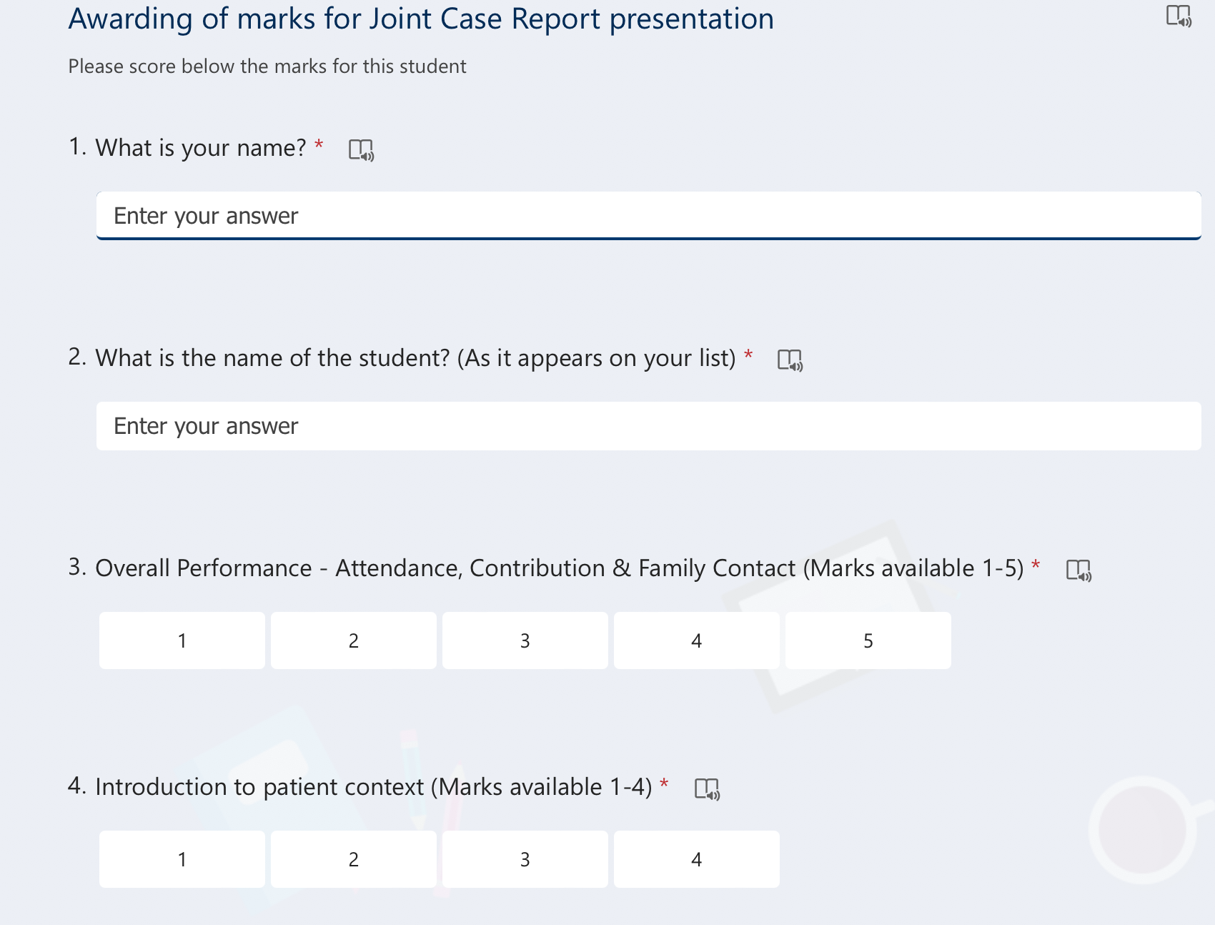
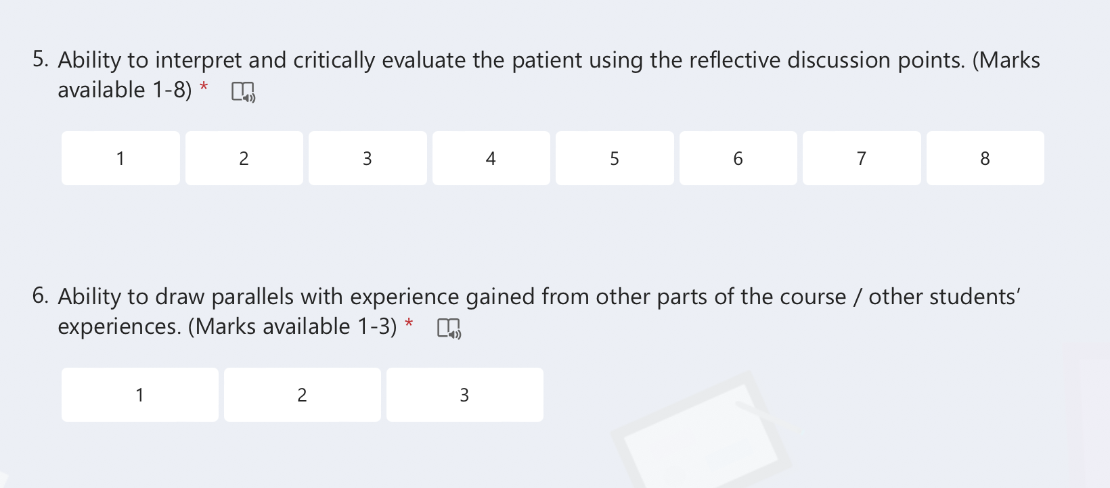

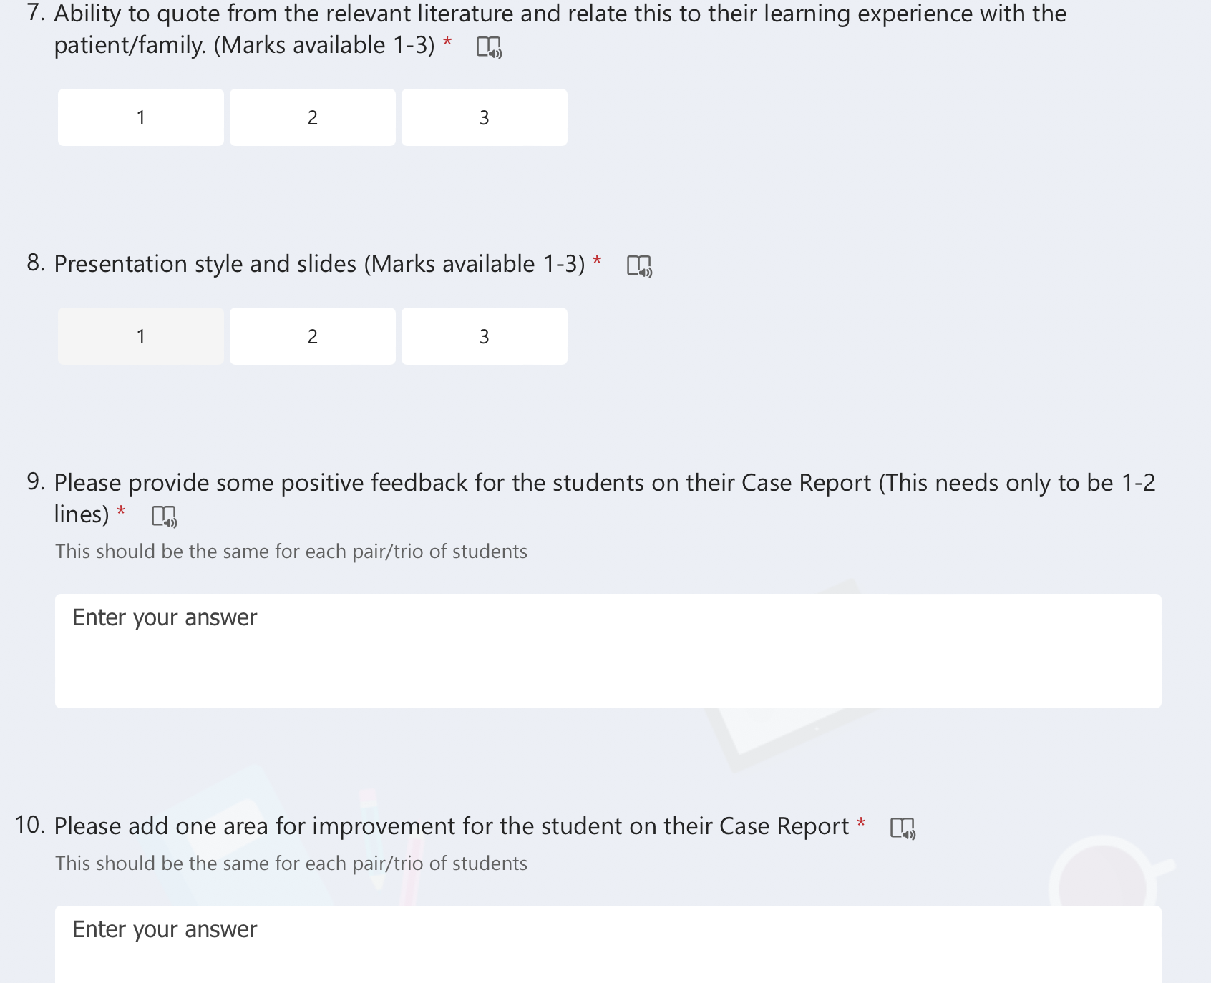
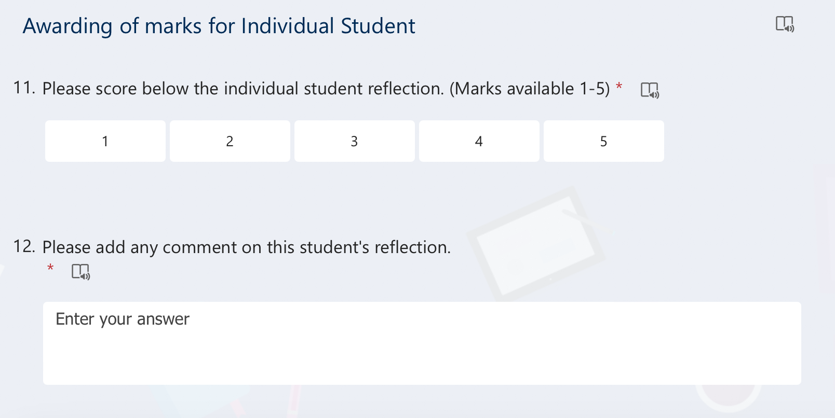

A Guide to the Individual Tutorials Year 2

Year 2 General Practice Experience
In second year, students will build on their experience of the Family Attachment Scheme with more focus on how General Practice delivers care to patients. In the Family Attachment component in first year, students will have been afforded important insights into how patients see their health and health care. In the second year, we will concentrate on how Primary Care is delivered to patients and how a patient’s needs are addressed in the community.

Preparing to receive students
Session 1 with be an Introduction to General Practice and to the module General Practice Experience. Session 2-4 will involve practice-based activities with a focus on learning from patients and members of the Primary Care team. Session 5 will be their Assessment. The presentations designed for use in the previous remote and hybrid modules have been incorporated into the first session, to allow the focus in Sessions 2-4 to be on people rather than PowerPoints! In the “Teaching General Practice” framework that I described in the introduction to this tutor guide, Year 2 Family Medicine is a natural home to realise the following aspiration, “We strongly recommend students being encouraged to consult with patients one-to-one from an early stage in training.”
It has been drawn to the students’ attention that students in different practices will have different experiences in this module. In addition, they are aware that the plan for their teaching might change if the clinical situation was to change. Some preparation in advance will be required to make best use of the time in Session 2-4, especially when involving members of the Primary Care team and patients.
In addition to involving other members of the Primary Care team with the students, you could consider involving some more senior medical students or trainees in teaching, as something that might spread the burden and be of mutual benefit.

Session 1 Introduction to General Practice Experience
This introductory session will be a practice tutorial, using a PowerPoint presentation led by yourself to allow some insight into what happens in the world of Primary Care and the multiplicity of roles that make up a day in General Practice.

Learning outcomes for this session are:
- To understand General Practice and how it meets patient needs
- To outline what distinguishes General Practice and Primary Care from hospital medicine and Secondary Care
- To learn how General Practice developed in the UK
- To develop a person-centred mindset by considering “the work of being a patient”
The session will be in two parts.
The first part will be the traditional talk on “The Essence of General Practice”, offering insights into the ethos and principles of General Practice including first point of contact, early undifferentiated illness, dealing with chronic disease, anticipatory care, registered patient population, continuity of care, the importance of good consultation skills etc. I have included some slides on the MDT and different modes of consultations, which were previously the focus of teaching in different Sessions. For anyone keen to do these in more details in Sessions 2-4, I have kept the Teaching Plans in Appendix 2 of this guide.
Some tutors may have their first year group from the previous year again, but for many students, your practice will be new to them. Tell them about yourself and your practice. Student feedback suggests that they enjoy hearing the variety of routes tutors have taken into General Practice, so I have included a slide to prompt you to talk a little about this. You can explain to them what will be expected of them in their final Session, as their assessment for the module. They will present on the below brief, individually, in pairs or trios, at your discretion.
The brief for the presentation is : “Using your experience in General Practice (both with patients and staff), how does General Practice provide person-centred care, population centred care and efficient delivery of care in community settings? Illustrate with examples from your time in General Practice Experience.”
The second part of the tutorial builds on the tutorial previously delivered as the “work of the patient”. At the end of the PowerPoint, there are some preliminary interactive exercises to get them thinking with some notes for tutors, asking students to discuss and put into a timeline what they think a patient “does” when they decide they need to see a GP. They might need some help getting started and jump to “phone the practice”, try to bring them back even to the point where they decide to seek help. The students as health literate, IT savvy, confident young people may see few problems with this. In the notes of the PowerPoint are a number of points you can use to challenge them on this e.g. what if they are a carer, what if they are agoraphobic. The idea is to help the students consider, using this as an example of something simple and seemingly routine like seeking an appointment, of some of the work that a patient does to manage their health and illness and to negotiate having their needs met in Primary Care. Please arrange to have a patient attend at this point of the Session (perhaps an hour in), who is happy to talk about what they have to do to manage their health in their experience and expertise. Listening to this patient will help the students reflect on what is involved in patienthood, within a person centred mindset.
Obviously, you will want the patient to lead this discussion but what you really want them to concentrate on is how they manage living with their illness. I suggest starting with asking them a little about how and when they were diagnosed, just for context. Then ask about a typical day for them – what you really want is how they live with their illness as opposed to clinical details that students can get from a textbook. This may need teased out a little as the patients are also probably not used to discussing this “hidden work” in detail or having anyone listen to them about it for any length of time! For example, if they say “I check my blood sugars twice a day” ask them to describe step by step what this actually means – when do they do it, where, how they do it, how does it feel and what they do with the result. Could they demonstrate it for the students? What you want is the behind-the-scenes information that doesn’t get written down anywhere and that students won’t learn about or appreciate otherwise.

Sessions 2-4 – Practice-based activities
These three Sessions provide the opportunities for the focus of the module, to learn about care within the practice and the community from both patients and practice staff. Feedback from students and GP tutors indicate that the most important thing in this module is patient contact. It is hoped that within these three Sessions the students get a number of opportunities for this. I suggest dividing the students into two or three groups depending on numbers. Whilst one subgroup is meeting a patient/patients, the other students can be rotating through a number of other practice-based activities which will be dictated by what is happening on that afternoon and who is present, in a working practice.
In the box below are a number of suggestions for what students could be doing in sub groups, whilst you are supervising students consulting with patients. It is recognised that the roll out of the MDT varies from practice to practice so for many practices this is limited to the more traditional Primary Care team. I have included home visits or accompanying a GP on Nursing Home visits as other possibilities, whatever reflects what is happening in the practice at that time.
Possible activities
- Observing members of the MDT, either clinical staff e.g. Practice Nurse, Treatment room Nurse, Practice Pharmacist or managerial/admin staff e.g. receptionist, Practice Manager
- Spending time observing the overall functioning of a patient e.g. in the Waiting Room
- Visit Family Attachment patients/families (if attached to the same practice) or visiting another patient at home where appropriate.
- Accompanying the GP visiting a Nursing Home

Patient consultations
In these Sessions, students will for the first time get to see how GPs consult in practice. Where possible, you may facilitate students to take part in a consultation, as part of a small group of students, under your supervision, either directly or indirectly. Patients will either have been chosen specially to come down to meet the students as ‘expert patients’ or they may be patients who have recently contacted the practice with a health need. You will need to consent them in advance that students will be present and taking part in their consultation. This opportunity to witness consultations aligns both with “becoming the student of the patient” from Cultural Humility and with developing a person-centred mindset.

Sessions 5 – Assessment
This final session will constitute the Assessment for General Practice Experience.

Assessment
Although you will have been assessing the students on a continuous basis, a specific assessment session will allow an opportunity for individual assessment and feedback. As part of the formal assessment, each student pair or trio, at your discretion, will deliver a 5-10-minute PowerPoint presentation drawing on their experience in the module.
As part of the continuous assessment, please assess the students on the following two parameters:
- Individual Contribution to tutorials
- Quality of end of course presentation
Each component need only be judged as satisfactory or unsatisfactory. You will be asked to provide some brief comments by way of feedback to the students on an MS form. An email with link to the forms will be sent in advance of this session.
Contribution to tutorials
You should consider attendance, participation, and engagement (as per the assessment sheet) to come to a decision about whether each student’s contribution was satisfactory.
End of course Presentation
The students have been given the following brief for their presentations.
“Using your experience in General Practice (both with patients and staff), how does General Practice provide person-centred care, population centred care and efficient delivery of care in community settings? Illustrate with examples from your time in General Practice Experience.”
You will receive the link for the MS form (on the next page) which is to be filled in for each student. It is recognised that students in pairs may get the same feedback. You can do this ‘live’ during the session or make a few notes and do this later.

Screenshot of MS form for marking
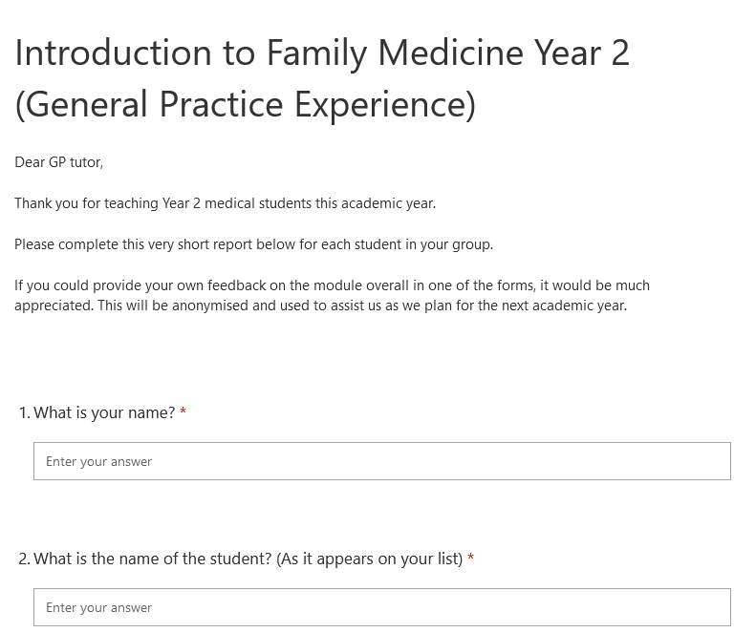
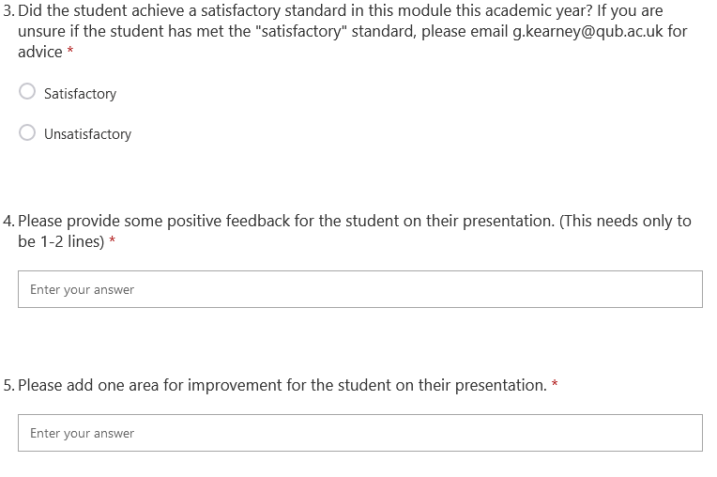
APPENDIX 1

Accessing the medical education online portal
Previously you only needed a generic username and password to access the medical education portal.
In recent years, the education portal has been through a major overhaul and has many new features. We have also implemented a more robust user authentication system which means that each user will have a unique username and password. Registering for this is simple. Go onto the site at https://www.med.qub.ac.uk/portal/ and follow the instructions below:
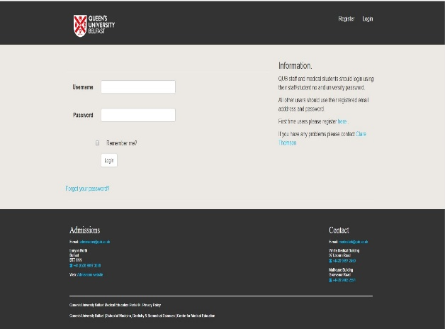 | Click on “Online Registration” form or “Register”  This will bring you to the registration form below
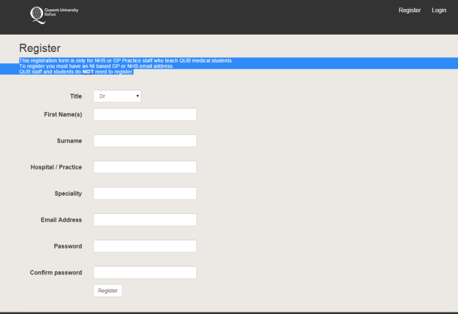 | Complete the registration form with your own details, select a password before clicking on “register”  at the bottom of the form.  Please note the following email address formats are  permitted:  (name of practice).gp.n-i.nhs.uk  (trust name).hscni.net  You may be able to register using another email address. Please  contact Eamon O’Hagan as per instructions on screen.
Once the registration form has been submitted an email which includes a confirmation link will be sent to your registered email address. Once you have clicked on this confirmation link you will have access to the portal.

APPENDIX 2 (not essential)

Teaching Plan - Modes of consultation

Plan
1 hour session delivered over zoom by GP tutor to their group of students
A framework PowerPoint will be supplied but the intention would be for an interactive discussion, peppered with the experiences of the tutor. Tutor may decide not even to put up the slides but just use as a prompt; to promote interaction, I have included the below prompt for interactive activities.

The slides are deliberately brief, I have included some suggestions in the notes below which tutors are welcome to use or ignore! For the suggested interactive elements, you can decide whether you do this just by students chipping in on their mics, using the chat function or even breakout rooms if you are comfortable with this.
NEW *Tutors and students have asked for increased clinical content in these sessions. For this tutorial, this is most easily achieved by you describing your clinical experiences for example of recent telephone consultations etc. I have included the below prompt for this in the relevant slides*

Additionally, in an attempt to involve patients in each session, it would be great if a patient with experience of different modes could link in to discuss their experiences of and the challenges of these, either in person or over zoom.

Aim of session
To introduce students to the variety of modes of consultations open to GPs and other clinicians and consider their advantages and pitfalls

Framework
- Aim of Session
- Background
- Interactive - Where do consultations take place in Primary Care?
- Interactive - Brainstorm the different modes of consultation – F2F, telephone, video, online/text based
Consider each in turn
- F2F
- Telephone (triage v consult)
- Video
- Online/text-based
- Interactive - Advantages
- Interactive - Pitfalls
- Interactive - Who might struggle
- Safety netting
- Interactive - FA over Zoom?
- Revisit Aim

Possible extension
The below resource on remote consultations and triage might be something that you want to refer students to either during or afterwards
https://elearning.rcgp.org.uk/mod/page/view.php?id=10812

Tutor tips from tutor feedback and tutor development meeting
- As above, include the GP’s experience and even patient experience where possible, in order to increase clinical content

Teaching Plan - The Multidisciplinary Team in Primary Care

Plan
1 hour session delivered over zoom by GP tutor to their group of students
A framework PowerPoint will be supplied but the intention would be for an interactive discussion, peppered with the experiences of the tutor. Tutor may decide not even to put up the slides but just use as a prompt; to promote interaction, I have included the below prompt for interactive activities.
The slides are deliberately brief, I have included some suggestions in the notes below which tutors are welcome to use or ignore! For the suggested interactive elements, you can decide whether you do this just by students chipping in on their mics, using the chat function or even breakout rooms if you are comfortable with this.
This session would be enhanced by some “live” appearances from other members of your Primary Care Team. Think about who the students would meet if they were in your practice for these tutorials – the practice nurse, the pharmacist, the practice manager, the treatment room nurse, the receptionist, perhaps even the physiotherapist and the social worker. Students will benefit from hearing about their roles especially specific examples of patients you have cared for as a team. They could link from anywhere, using the Zoom links that the student has used. I have not included this in the PowerPoint that I have prepared as this will be different practice to practice.
NEW *Tutors and students have asked for increased clinical content in these sessions. For this tutorial, this is most easily achieved by you and the other practitioners describing your clinical experiences, working as a team, referring (anonymously of course) to specific patient interactions. I have included the below prompt for this in the relevant slides*

Additionally, in an attempt to involve patients in each session, it would be great if a patient with experience of the MDT could link in to discuss their experiences, either in person or over zoom.

Aim of session
To introduce students to the multidisciplinary team in Primary Care and consider how they meet patients’ needs together.

Framework
- Aim of Session
- Background
- Interactive - where do members of the Primary Care Team work?
- Interactive - Brainstorming the MDT – students can share their experiences of this
- Clinical staff (in the practice)
- Admin/Managerial staff
- The Wider Community Team
- Explore an example where the broader MDT meets the needs of a patient with a chronic health condition e.g. Diabetes
- MDT initiative
- Interactive – the advantages and disadvantages, from the students’ perspective
- Revisit aim

Possible extension
The below resource on MDTs might be something that you want to refer students to either during or afterwards.
https://www.health-ni.gov.uk/publications/general-practice-multi-disciplinary-teams-general-leaflet

Tutor tips from tutor feedback and tutor development meeting
- Session works well fully remote due to convenience for MDT
- Scope for broadening who is involved with increased uptake of MDT
- As above, include practitioner’s experience and even patient experience where possible, in order to increase clinical content

APPENDIX 3
Accessed from https://www.qub.ac.uk/sites/qubgp/Resources/, see website for up to date version
Home visits
The GP consultation is at the heart of general practice, but the number of home visits undertaken is reducing, primarily due to workload pressures. Home visits provide unique rich learning opportunities for undergraduates. These include: -
- Learning about the patient (in reality) - lifestyle, medication concordance, level of functioning in their home setting
- Learning about the patient’s home environment (in reality) – relatives/carers/primary care team, deprivation, aids/appliances/adaptations, etc.
- Developing individual consultation skills and professional values
Feedback from our medical students across all year groups consistently demonstrates that they enjoy and value seeing patients in their own home.
Home visits tend to fall into 2 groups: -
- Reactive (acute deterioration in health)
- Pro-active (post hospital discharge/chronic condition management when patient unable to attend surgery/palliative care)
For new practices (and those who perhaps haven’t sent students on home visits before), we thought it would be helpful to share a suggested checklist for any GP allocating medical students for a home visit. If you have any ideas/suggestions to add, please let me know.
- Seek patient verbal consent in advance of the home visit (example letter template to patient below, or could include essential info in a text)
- Agree time of visit and check who else will be in the home at the time/any animals?
- Students should complete a home visit in a minimum of two
- Check if students have their own transport or if it is within easy walking distance or can be accessed by public transport within a reasonable timeframe.
- Discuss specific tasks for home consultation e.g. Long term condition or multimorbidity information gathering; see student checklist and suggested reflective template.

Letter Template to patient who has agreed to have home visit by QUB medical students
Thank you for agreeing to talk with medical students from Queen’s University, Belfast.
We have asked your GP to find some patients who are willing to spend time talking with medical students for two very important reasons.
First, so that students may learn from your experiences of illness and second, so that the students can improve their communication skills when talking to patients about their health.
Please remember that some of these students are still early in their medical training. They have had limited opportunities to speak to “real patients” and they will not be able to answer any medical questions that you might have about your health. Some students will be very shy. If you are chatty and open this will really help to keep the conversation going!
After the home visit, the students will be asked by the GP to reflect on what they have heard, and the GP may also discuss this with other students placed in the practice. We always keep your information confidential by changing key identifying factors such as names, ages and places.
Please inform the GP or the students if you would not like them to share your story anonymously.
With many thanks,
GP on behalf of the Practice

We want to ensure our medical students are adequately prepared for their home visit, so have created a checklist below. Please share any ideas/suggestions. We have also provided a reflective template to help them record their experience.
BEFORE home visit
- Ensure you have patient contact information (address including post code and phone number)
- Confirm with GP the time you are expected to arrive at the home and time you should be back at the practice, if expected back.
- Check if you need any patient summary notes provided by the GP.
- Have a mobile telephone with a contact number for the practice.

AT home visit
- Ensure on entering the house you are speaking to the correct person, confirm with name and date of birth and ensure that they are expecting you.
- 'A picture paints a thousand words.' Look around to see what you can learn about the patient and their condition from their home life.
- Consider falls risks, sensory impairment, ability to manage ADLs
  - Are there stairs/handrail?
  - Are there home modifications?
- Consider medication and who administers/orders meds.
- Consider state of home
  - Is it an area of deprivation or affluence?
  - is it warmer or colder than expected?
  - Is it tidy/organised/disorganised?
  - Is it in disrepair or good condition?
  - does the patient cook or how are nutritional needs met?
- Make a note of any other relatives or carers who are also at home. If alone, who is their emergency support person?
- Consider how you vary your consultation style to suit the home environment.
- Physical examination: You will be guided by your GP tutor as to whether targeted physical examination should be performed. With patient consent you can carry out the following observations on any patient.
- Pulse
- BP
- Oxygen saturation
- Resp rate
- weight
- Do not perform any intimate physical examination in the home.

AFTER home visit
- Debrief with GP tutor – use reflective home visits template.
- Ensure all documentation relating to the visit is shredded at the practice.

Reflective Home Visit Template
Date

Patient’s age/sex/ethnicity

Brief summary of patients’ story.

Any other issues raised.

What did I do well?

Anything I will do differently on the next home visit?

One thing which challenged me.

One thing which surprised me.

What have I learned?

How did this visit make me feel?

Appendix 4 – Consent form for Family Attachment scheme

Preliminary Consent:

I / We ________________________________________________

(Name(s))

of _________________________________________________

(Address)

do hereby consent to receiving contacts from:

First year medical students

I / we understand that the purpose of their contacts is to learn about our medical and social history to the extent I am prepared to divulge. I understand that the students will keep what they learn from me confidential and will not divulge this to others excepting in the context of a teaching session.

I / we are happy to allow the students to consult my medical notes under the supervision of the General Practitioner Tutor. I understand I can withdraw this permission at any time.

